Open bit bucket with dipkundu credentials

Goto Astha’s branch repo whose branch you want to fork

Create a new fork request

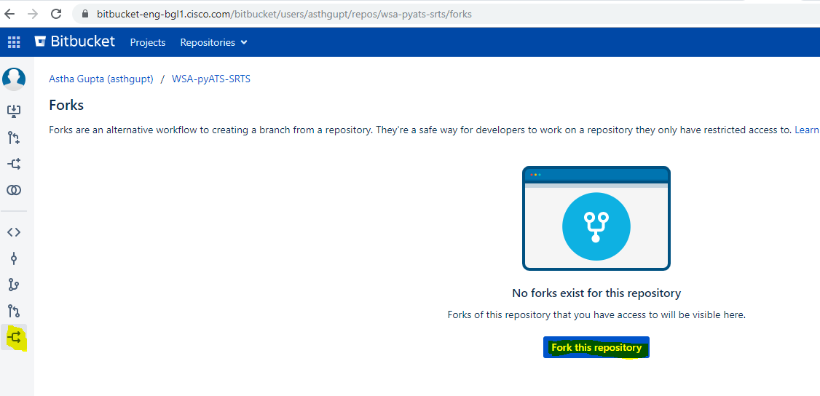

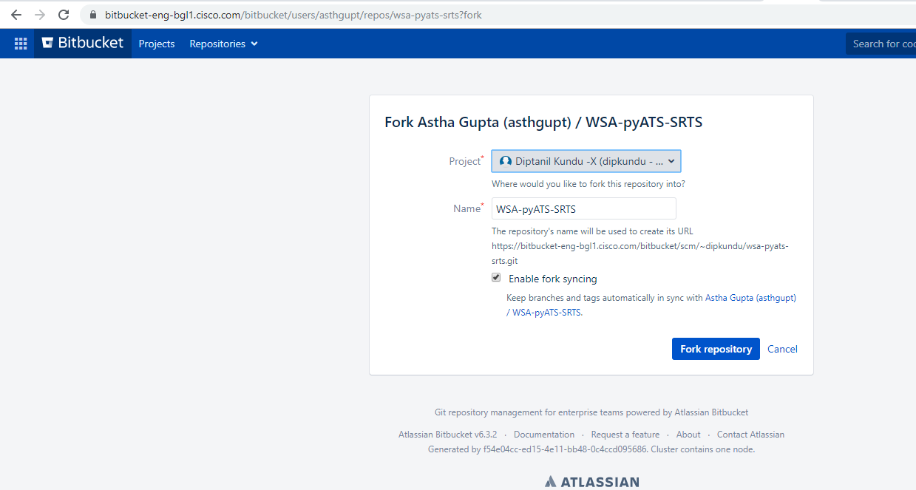

Now Clone:

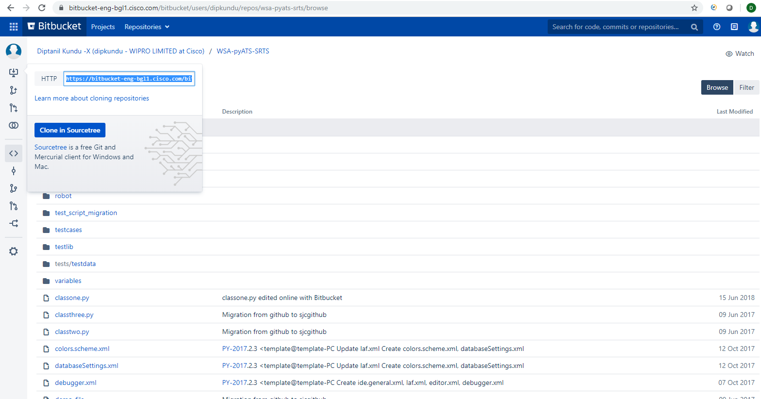

Now open wsa040-client05.cs1 or ssh with its ip: 10.10.4.230

git config --global user.name "Diptanil"

git config --global user.email dipkundu@cisco.com

git clone https://bitbucket-eng-bgl1.cisco.com/bitbucket/scm/~dipkundu/wsa-pyats-srts.git

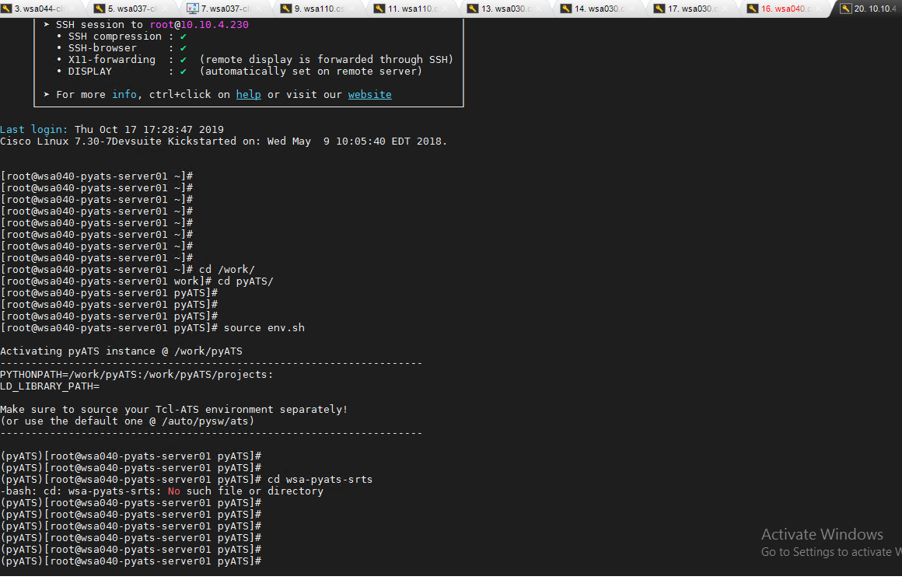

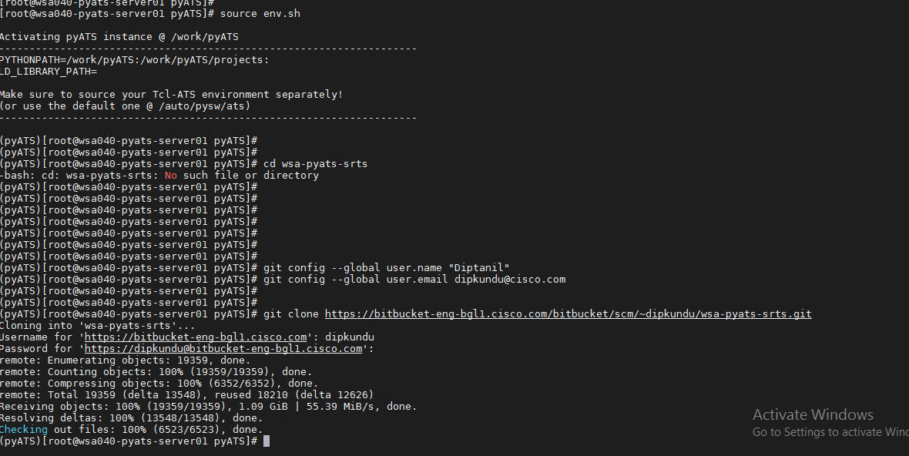

[testuser@wsa040-pyats-server01 pyATS]$ cd wsa-pyats-srts

[testuser@wsa040-pyats-server01 wsa-pyats-srts]$

[testuser@wsa040-pyats-server01 wsa-pyats-srts]$ git branch

* master

[testuser@wsa040-pyats-server01 wsa-pyats-srts]$

Now create test cases under this folder

For creating PYATS server:

First check if any one ip of your wsa is free,in my case wsa 040-client05.cs1 was free. Do nslookup and check the ip from any client machine. Wsa044-client01 and take the ip and check in vmware if any machine is allocated or not. If its free the clone pyats019 (kowshik) wsa or wsa 030-client01 (samita) and then edit the vlan network adapter 1 with wsa040 once deploy completed. Then turn on the machine nd open console and change the hostname and restart. Also check the configurations in vi /etc/sysconfig/network-scripts/ifcfg-ens160

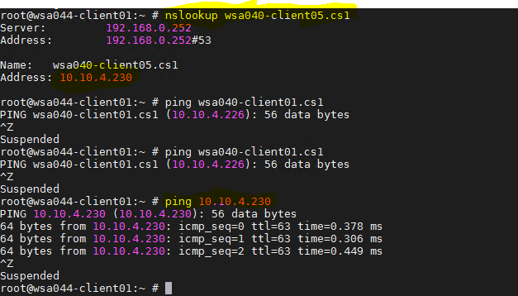

Start source env.sh first

[root@wsa040-pyats-server01 ~]# cd /work/

[root@wsa040-pyats-server01 work]# cd pyATS/

[root@wsa040-pyats-server01 pyATS]#

[root@wsa040-pyats-server01 pyATS]#

[root@wsa040-pyats-server01 pyATS]#

[root@wsa040-pyats-server01 pyATS]# source env.sh

Activating pyATS instance @ /work/pyATS

--------------------------------------------------------------------

PYTHONPATH=/work/pyATS:/work/pyATS/projects:

LD_LIBRARY_PATH=

Make sure to source your Tcl-ATS environment separately!

(or use the default one @ /auto/pysw/ats)

--------------------------------------------------------------------

(pyATS)[root@wsa040-pyats-server01 pyATS]#

Goto home/testuser and then start selenium server

[root@wsa037-client05 wsa-pyats-srts_ise1180]# pwd

/work/pyATS/wsa-pyats-srts_ise1180

[root@wsa037-client05 wsa-pyats-srts_ise1180]# cd ../../../

[root@wsa037-client05 /]# cd home

[root@wsa037-client05 home]# pwd

/home

[root@wsa037-client05 home]# cd testuser/

[root@wsa037-client05 testuser]# java -jar

.bash_history Documents/ Music/ Templates/

.bash_logout Downloads/ Pictures/ --tls-max

.bash_profile .esd_auth .pki/ Videos/

.bashrc .ICEauthority Public/ .viminfo

.cache/ id_rsa.pub review_logs/ .vnc/

.config/ .local/ selenium-server-standalone-2.52.0.jar .Xauthority

Desktop/ .mozilla/ .ssh/

[root@wsa037-client05 testuser]# java -jar selenium-server-standalone-2.52.0.jar port 4444

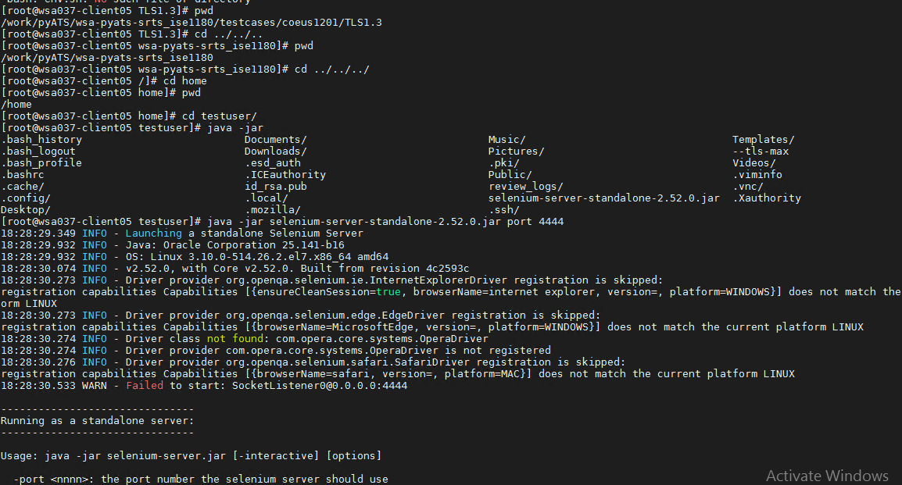

Ssh to wsa040.client05.cs1 with testuser/ironport

**Start VNC** with the **vncserver** command.

Password ironport

Ssh vnc with wsa040-client05.cs1 with port 5901

Before running easypy job from root user export the two variables:

export SLICE_SERVER=<the webserver of the wsa slot which is pingable>     (for me it was wsa003-server01.cs20)

export WORKSPACE=/work/pyATS/wsa-pyats-srts_ise1180

Running easypy job from your workspace

(pyATS)[root@wsa003-pyats-server01 wsa-pyats-srts_ise1180]# /work/pyATS/bin/easypy testcases/coeus1201/TLS1.3/job_tls_1_3_versioncompatiblity_guisuite.py --wsa_version=12.0.1-161 --dut_version=coeus1201

Basic git commands:

<https://confluence.atlassian.com/bitbucketserver/basic-git-commands-776639767.html>

root@wsa037-client05 TLS1.3]#

[root@wsa037-client05 TLS1.3]# echo $WORKSPACE

[root@wsa037-client05 TLS1.3]# echo $SLICE_SERVER

[root@wsa037-client05 TLS1.3]# export SLICE_SERVER=wsa044-client01.cs1

[root@wsa037-client05 TLS1.3]#

[root@wsa037-client05 TLS1.3]#

[root@wsa037-client05 TLS1.3]# export WORKSPACE= /work/pyA

pyAts pyATS/

[root@wsa037-client05 TLS1.3]# export WORKSPACE= /work/pyA

pyAts pyATS/

[root@wsa037-client05 TLS1.3]# export WORKSPACE= /work/pyA

pyAts pyATS/

[root@wsa037-client05 TLS1.3]# export WORKSPACE= /work/pyATS/wsa-pyats-srts

wsa-pyats-srts/ wsa-pyats-srts_ise1180/ wsa-pyats-srts-tls/

[root@wsa037-client05 TLS1.3]# export WORKSPACE= /work/pyATS/wsa-pyats-srts

wsa-pyats-srts/ wsa-pyats-srts_ise1180/ wsa-pyats-srts-tls/

[root@wsa037-client05 TLS1.3]# export WORKSPACE= /work/pyATS/wsa-pyats-srts

wsa-pyats-srts/ wsa-pyats-srts_ise1180/ wsa-pyats-srts-tls/

[root@wsa037-client05 TLS1.3]# export WORKSPACE= /work/pyATS/wsa-pyats-srts

wsa-pyats-srts/ wsa-pyats-srts_ise1180/ wsa-pyats-srts-tls/

[root@wsa037-client05 TLS1.3]# export WORKSPACE= /work/pyATS/wsa-pyats-srts

wsa-pyats-srts/ wsa-pyats-srts_ise1180/ wsa-pyats-srts-tls/

[root@wsa037-client05 TLS1.3]# export WORKSPACE= /work/pyATS/wsa-pyats-srts_ise1180/

-bash: export: `/work/pyATS/wsa-pyats-srts_ise1180/': not a valid identifier

[root@wsa037-client05 TLS1.3]#

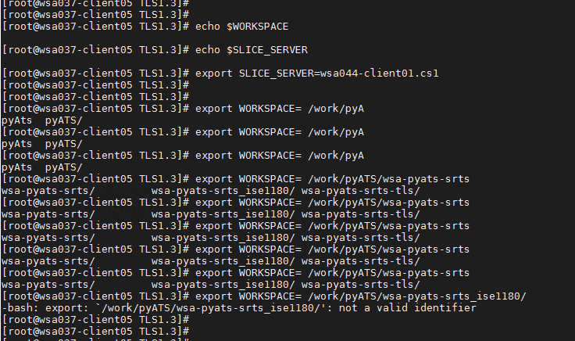

export SLICE_SERVER=wsa040-client05.cs1

RUNNING EASY PY:

LOGIN AS ROOT USER

[root@wsa037-client05 ~]#

[root@wsa037-client05 ~]# export SLICE_SERVER=apache-webserver-tls13.cs1

[root@wsa037-client05 ~]# export WORKSPACE=/work/pyATS/wsa-pyats-srts_ise1180

FROM pyATS run source env2.sh first

[root@wsa037-client05 pyATS]# source env2.sh

Activating pyATS instance @ /work/pyATS

--------------------------------------------------------------------

PYTHONPATH=/work/pyATS:/work/pyATS/projects:

LD_LIBRARY_PATH=

Make sure to source your Tcl-ATS environment separately!

(or use the default one @ /auto/pysw/ats)

Then go and run the script from

pyATS)[root@wsa037-client05 pyATS]# cd wsa-pyats-srts_ise1180/

(pyATS)[root@wsa037-client05 wsa-pyats-srts_ise1180]# /work/pyATS/bin/easypy testcases/coeus1201/TLS1.3/job_tls_1_3_decrypt_endusernotification_explicit.py --wsa_version=12.0.1-161 --dut_version=coeus1201

2019-10-21T12:06:49: %easypy-INFO: Starting job run: job_tls_1_3_decrypt_endusernotification_explicit

2019-10-21T12:06:49: %easypy-INFO: Starting task execution: __task1

2019-10-21T

GIT PUSH :

First GITPULL before pushing.(check location from where the pull will happen ..refer image)

FIRST RUN THIS AND CHECK WHICH USER NAME IS BEING USED :

git config user.name

THEN CHECK THE GIT BRANCH YOU ARE IN:

Gitbranch

THEN ADD THE TEST CASES YOU WANT TO PUSH:

git add testcases/coeus1201/TLS1.3/job_tls_1_3_decrypt_endusernotification_explicit.py

git add testcases/coeus1201/TLS1.3/tls_1_3_decrypt_endusernotification_explicit.py

Commit with msg:

git commit -m "Adding changes based on review comments for TLS 1.3 test cases and job files for tls_1_3_decrypt_endusernotification_explicit"

git push origin TLS1.3

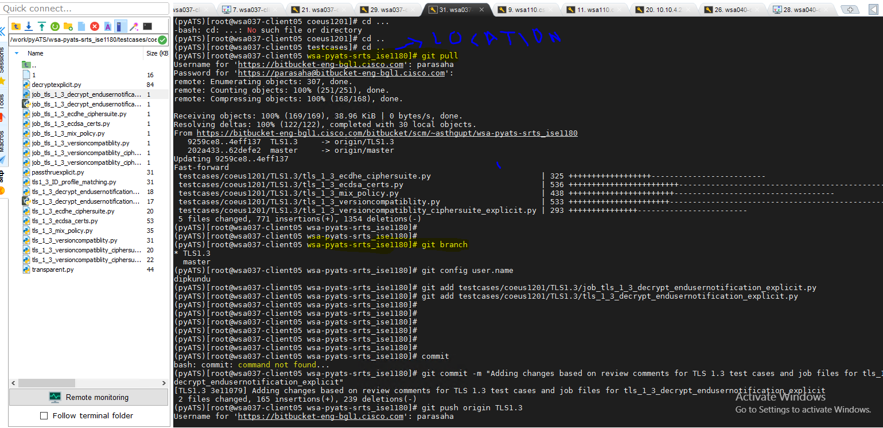

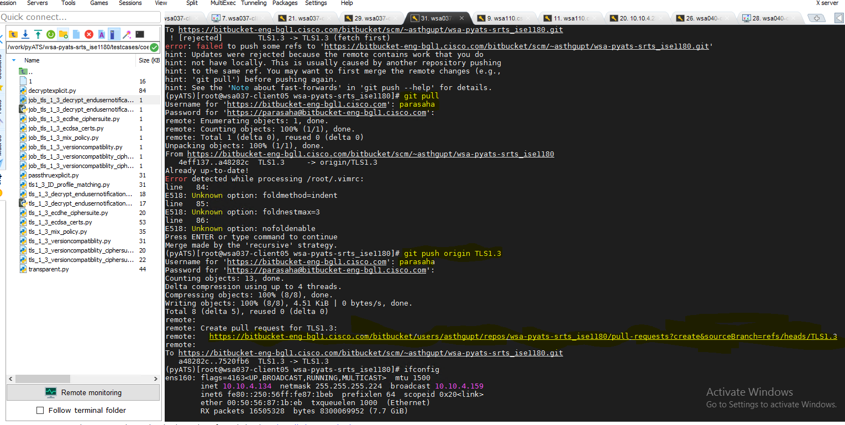

Easypy running from VNC if failing:

If your UI is not opening while running the easypy job then check the selenium host in both the scripts if it is correct or not

PARSER.add_argument('--host', help='selenium_host', default='wsa037-client05.cs1')

Saving the logs of easypy

location :

/work/pyATS/users/root/archive/19-10/PassedlogsTLS

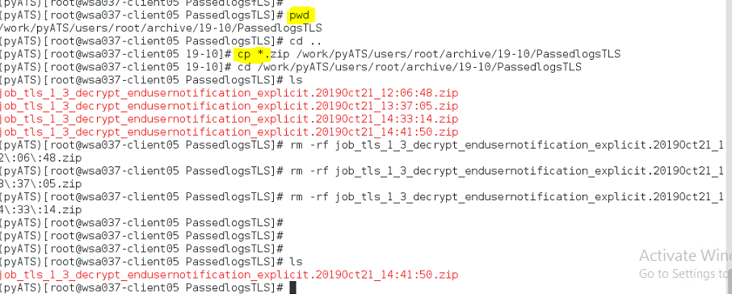

Where the selenium server is running there the browser will launch

To know the pid $ px -ox | grep -irn 'Selenium Server'

Then kill

For windows: process name javac

taskkill /F /PID pid_number

taskkill /F /PID 1242

NOTE:

Delete tmp file from root and the do netinstall:

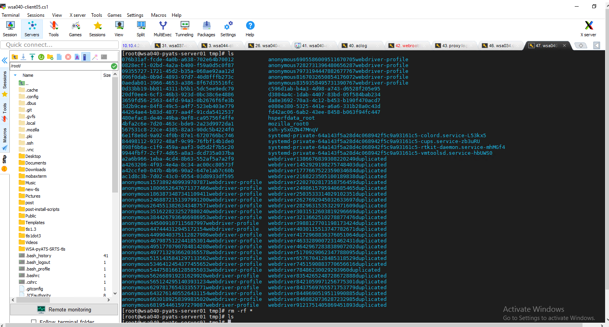

KILLING SELENIUM SERVER:

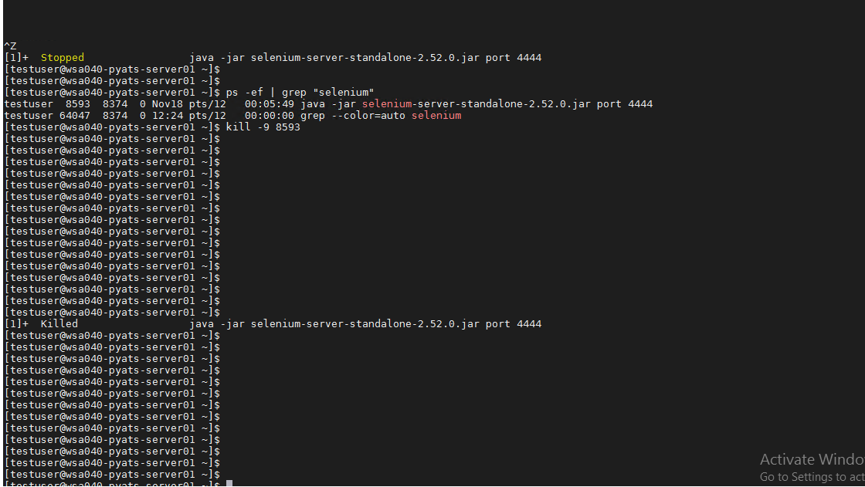

[testuser@wsa040-pyats-server01 ~]$

[testuser@wsa040-pyats-server01 ~]$ **ps -ef | grep "selenium"**

testuser 8593 8374 0 Nov18 pts/12 00:05:49 java -jar selenium-server-standalone-2.52.0.jar port 4444

testuser 64047 8374 0 12:24 pts/12 00:00:00 grep --color=auto selenium

[testuser@wsa040-pyats-server01 **~]$ kill -9 8593**

[testuser@wsa040-pyats-server01 ~]$

[testuser@wsa040-pyats-server01 ~]$

[1]+ Killed java -jar selenium-server-standalone-2.52.0.jar port 4444

[testuser@wsa040-pyats-server01 ~]$

[testuser@wsa040-pyats-server01 ~]$

Debugging easypy runtime error:

ALWAYS RUN EASYPY FROM ROOOTTTTTTTT, GIVE THE COMMAND EASYPY

Always check the workspace before running

(pyATS)[root@wsa040-pyats-server01 wsa-pyats-srts]#

(pyATS)[root@wsa040-pyats-server01 wsa-pyats-srts]# echo $WORKSPACE

/work/pyATS/wsa-pyats-srts_ise

(pyATS)[root@wsa040-pyats-server01 wsa-pyats-srts]# pwd

/work/pyATS/wsa-pyats-srts

(pyATS)[root@wsa040-pyats-server01 wsa-pyats-srts]# export WORKSPACE=/work/pyATS/wsa-pyats-srts ->>>>>>>>>>change it to correct workspace if its incorrect.

(pyATS)[root@wsa040-pyats-server01 wsa-pyats-srts]#

(pyATS)[root@wsa040-pyats-server01 wsa-pyats-srts]#

(pyATS)[root@wsa040-pyats-server01 wsa-pyats-srts]# echo $WORKSPACE

/work/pyATS/wsa-pyats-srts

(pyATS)[root@wsa040-pyats-server01 wsa-pyats-srts]# easypy testcases/coeus1201/webrootdip/job_webroot_proxid_match.py --wsa_version=12.5.0-153 --dut_version=coeus1201

[testuser@wsa040-pyats-server01 webrootdip]$ git status |more

# On branch master

# Changes not staged for commit:

# (use "git add <file>..." to update what will be committed)

# (use "git checkout -- <file>..." to discard changes in working directory)

#

# modified: ../../../testlib/coeus1201/cli/ctor/advancedproxyconfig.py

# modified: ../../../testlib/coeus1201/cli/ctor/commit.py

# modified: ../../../testlib/coeus1201/cli/ctor/upgrade.py

# modified: ../../../testlib/coeus1201/cli/keywords/advanced_proxy_config.py

# modified: ../../../testlib/coeus1201/cli/keywords/commit.py

# modified: ../../../testlib/coeus1201/cli/keywords/upgrade.py

# modified: ../../../testlib/coeus1201/gui/admin/system_upgrade.py

#

Giving permission in bitbucket repo:

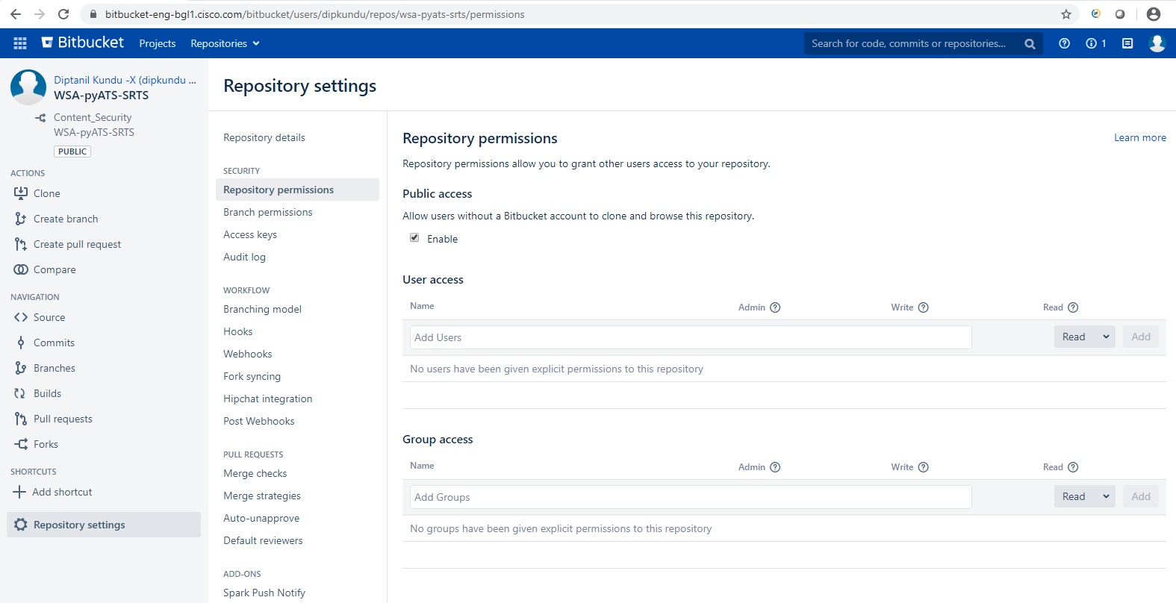

New workspace:

/home/testuser/wsa-pyats-srts-ssd/testcases/coeus1201/ssdbackup

source /work/pyATS/env.sh --🡪 if you are running from a different location or repo

git diff --base testlib/coeus1201/gui/admin/system_upgrade.py

Adding files in git hub …first git pull..if error in git pull take backup and and hard reset the repo ,check bitbucket setting if its synced with the content security. Check commits of both content security and your repo ..it should be same if its synced…

Paste those files in your repo again after the hard reset and then commit and push. Don’t create the pull request until final review. 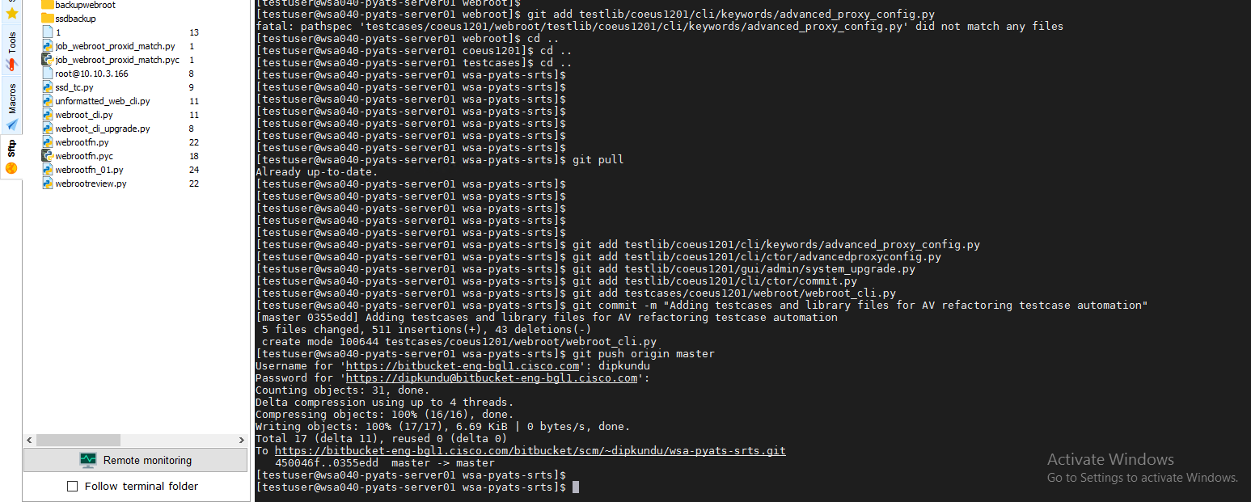

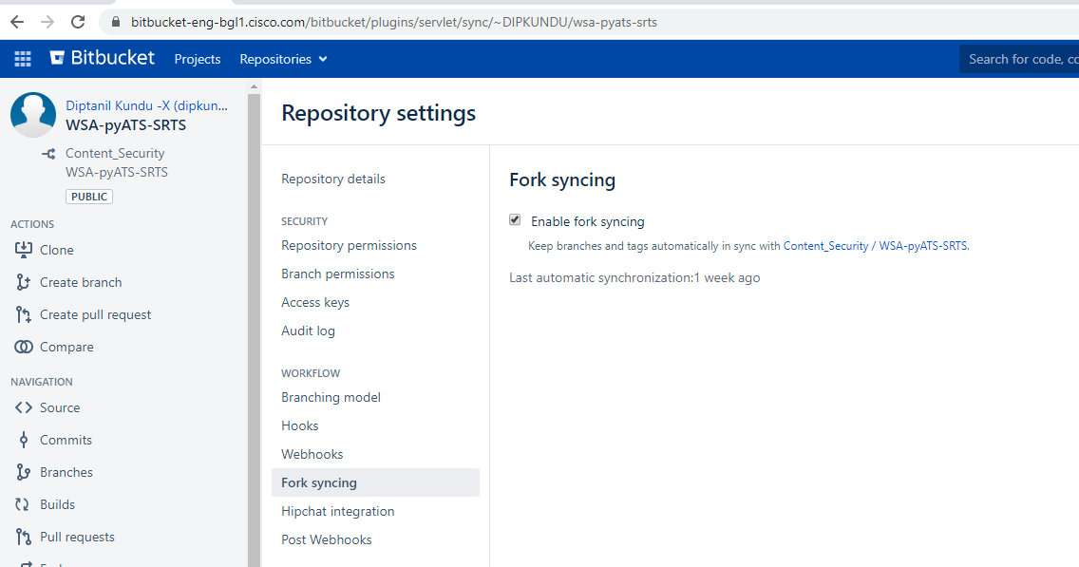

git branch ->>>master

git add testlib/coeus1201/cli/keywords/advanced_proxy_config.py

git add testlib/coeus1201/cli/ctor/advancedproxyconfig.py

git add testlib/coeus1201/gui/admin/system_upgrade.py

git add testlib/coeus1201/cli/ctor/commit.py

git add testcases/coeus1201/webroot/webroot_cli.py

git commit -m "Adding testcases and library files for AV refactoring testcase automation"

git push origin master

<https://confluence.atlassian.com/bitbucketserver/basic-git-commands-776639767.html>

before netinstall:

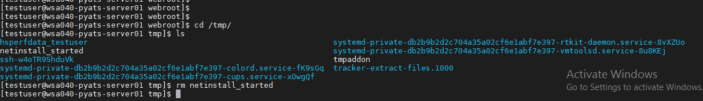

Git rename:

[testuser@wsa040-pyats-server01 wsa-pyats-srts]$ git mv testcases/coeus1201/webroot/webrootfn.py testcases/coeus1201/webroot/webroot_sync_uid.py

[testuser@wsa040-pyats-server01 wsa-pyats-srts]$ git commit -m "Rename webrootfn.py to webroot_sync_uid.py"

[master 69c1686] Rename webrootfn.py to webroot_sync_uid.py

1 file changed, 0 insertions(+), 0 deletions(-)

rename testcases/coeus1201/webroot/{webrootfn.py => webroot_sync_uid.py} (100%)

[testuser@wsa040-pyats-server01 wsa-pyats-srts]$ git push origin master

Username for 'https://bitbucket-eng-bgl1.cisco.com': dipkundu

Password for 'https://dipkundu@bitbucket-eng-bgl1.cisco.com':

Counting objects: 9, done.

Delta compression using up to 4 threads.

Compressing objects: 100% (5/5), done.

Writing objects: 100% (5/5), 471 bytes | 0 bytes/s, done.

Total 5 (delta 4), reused 0 (delta 0)

To https://bitbucket-eng-bgl1.cisco.com/bitbucket/scm/~dipkundu/wsa-pyats-srts.git

692304c..69c1686 master -> master

GIT Delete:

[testuser@wsa040-pyats-server01 wsa-pyats-srts]$ git rm testcases/coeus1201/webroot/webroot_async_scan.py

rm 'testcases/coeus1201/webroot/webroot_async_scan.py'

[testuser@wsa040-pyats-server01 wsa-pyats-srts]$ git commit -m "Removing duplicate testcases for webroot async scan request"

[testuser@wsa040-pyats-server01 wsa-pyats-srts]$ git push origin master

Username for 'https://bitbucket-eng-bgl1.cisco.com': dipkundu

Password for 'https://dipkundu@bitbucket-eng-bgl1.cisco.com':

Counting objects: 9, done.

Delta compression using up to 4 threads.

Compressing objects: 100% (5/5), done.

Writing objects: 100% (5/5), 449 bytes | 0 bytes/s, done.

Total 5 (delta 4), reused 0 (delta 0)

To https://bitbucket-eng-bgl1.cisco.com/bitbucket/scm/~dipkundu/wsa-pyats-srts.git

375f85b..692304c master -> master

[testuser@wsa040-pyats-server01 wsa-pyats-srts]$

GIT PULL ERROR:

git pull

remote: Enumerating objects: 87, done.

remote: Counting objects: 100% (75/75), done.

remote: Compressing objects: 100% (43/43), done.

remote: Total 46 (delta 34), reused 0 (delta 0)

error: insufficient permission for adding an object to repository database .git/objects

fatal: failed to write object

fatal: unpack-objects failed

su root

and then git pull

this is a permission error.

GIT UNDO BEFORE COMMIT :

git reset <file>

git reset advanced_proxy_config.pyc

*FIND AND KILL THE PROCESS***********************************************************************

root@wsa034-client01:~/samita_slow # ps -aux

USER PID %CPU %MEM VSZ RSS TT STAT STARTED TIME COMMAND

root 10 390.0 0.0 0 64 - RL 3Mar20 362572:56.18 [idle]

smmsp 53350 13.0 0.1 27384 7172 - D 4:36AM 0:03.05 sendmail: ./0419aviT030073 from queue (sendmail)

root 0 0.0 0.0 0 176 - DLs 3Mar20 41:15.17 [kernel]

root 1 0.0 0.0 9472 728 - ILs 3Mar20 0:01.49 /sbin/init --

root 2 0.0 0.0 0 32 - DL 3Mar20 29:42.20 [cam]

root@wsa034-client01:~/samita_slow # kill -9 52395

**************************************git cert error:****************

git config http.sslVerify false

synchronization

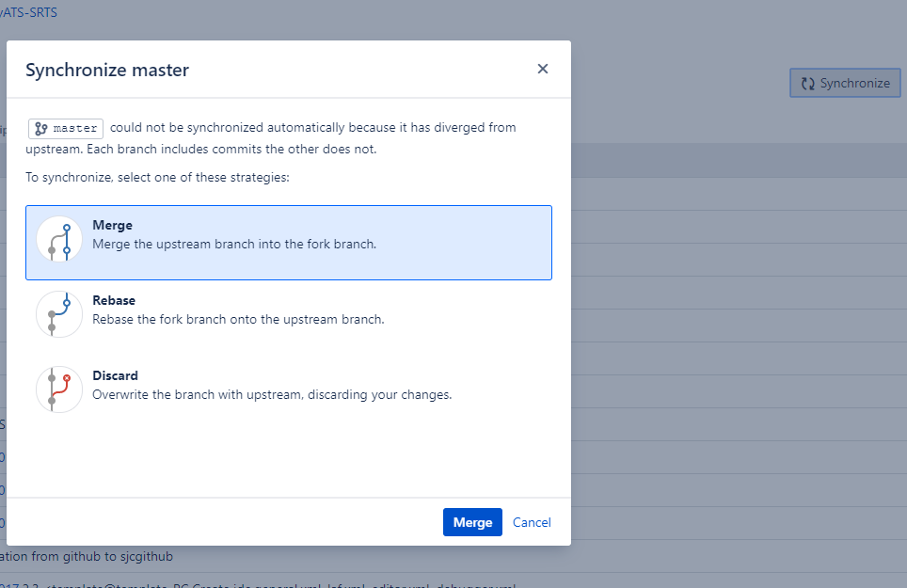

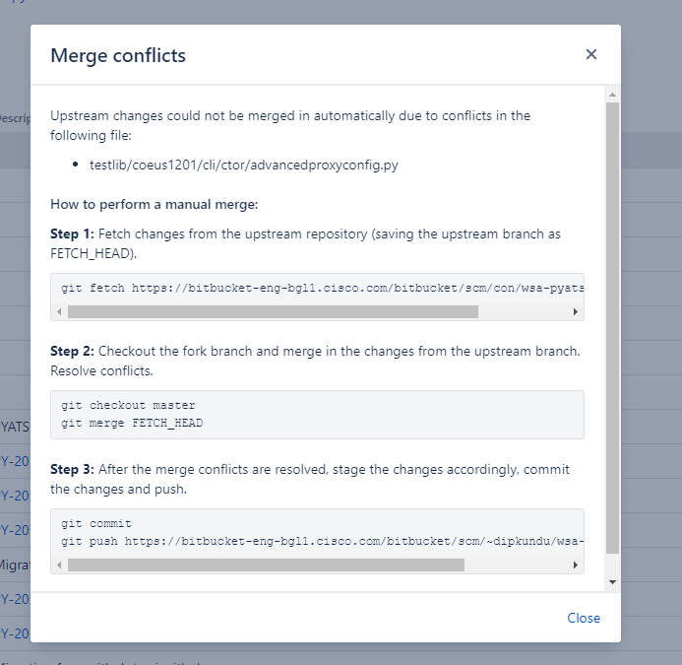

CLONE A PYATS SERVER:

CHANGE THE VLAN FIRST,THEN POWER ON THE NEW DEVICE.

NETWORK SCRIPTS:

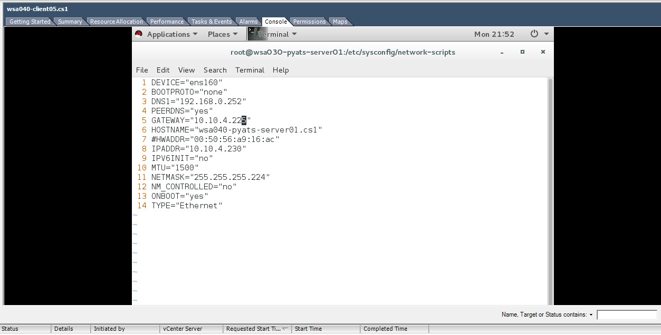

GATEWAY WILL BE 1- CLIENT 01 , OR 5 – CLIENT05, NSLOOKUP KORE CHECK KORO CLIENT01 AND 05 ER IP KOTO, CHANGE HOSTNAME AND IP ADDRESS.

FROM A DIFFERENT CLIENT ,

AND SWITCH OFF THE PYATS SERVER FROM WHERE YOU ARE CLONING THE NEW PYATS SERVER, AFTER YOU CHANGE THE IP THEN POWER ON THE OLD DEVICE.

nslookup -type=any wsa040-client01.cs1

nslookup -type=any wsa040-client05.cs1

ip address will be same as nslookup output:tis is for client01…gateway will always be same for all clients,so client01 -1 ,client02-2,client05-5

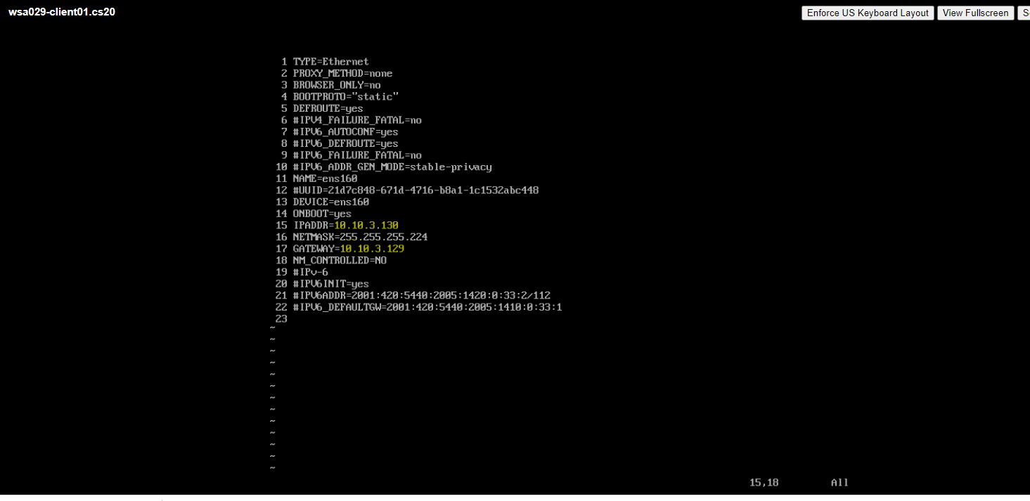

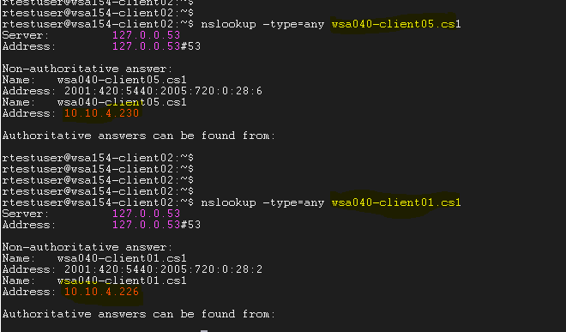

CentOS CLIENT AND SERVER CONFIGURATIONS:  
  
Login via testuser:  
  
sudo vi /etc/hostname  
  
cd /etc/sysconfig/network-scripts  
  
sudo vi ifcfg-ens160  
  
sudo /etc/init.d/network restart  
  
ifconfig ens160  
  
netstat -nr  
reboot  
ping wsa016.cs3  
ping client  
  
wsa060.cs1  
  
  
cisco123$

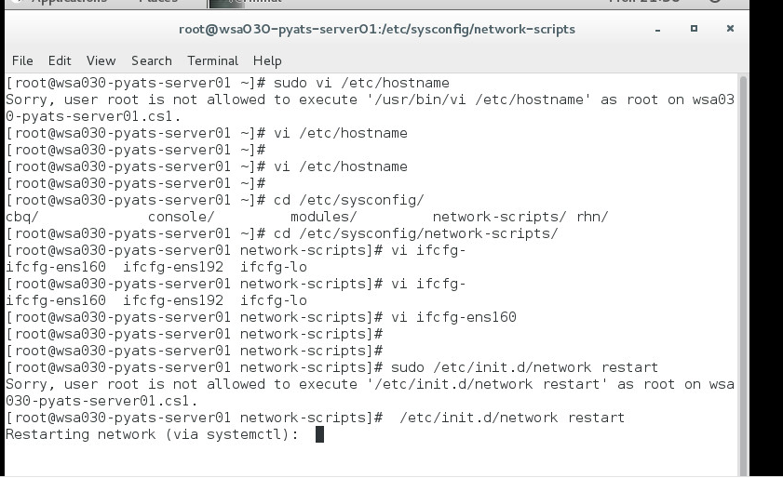

BITBUCKET PULL REQ:

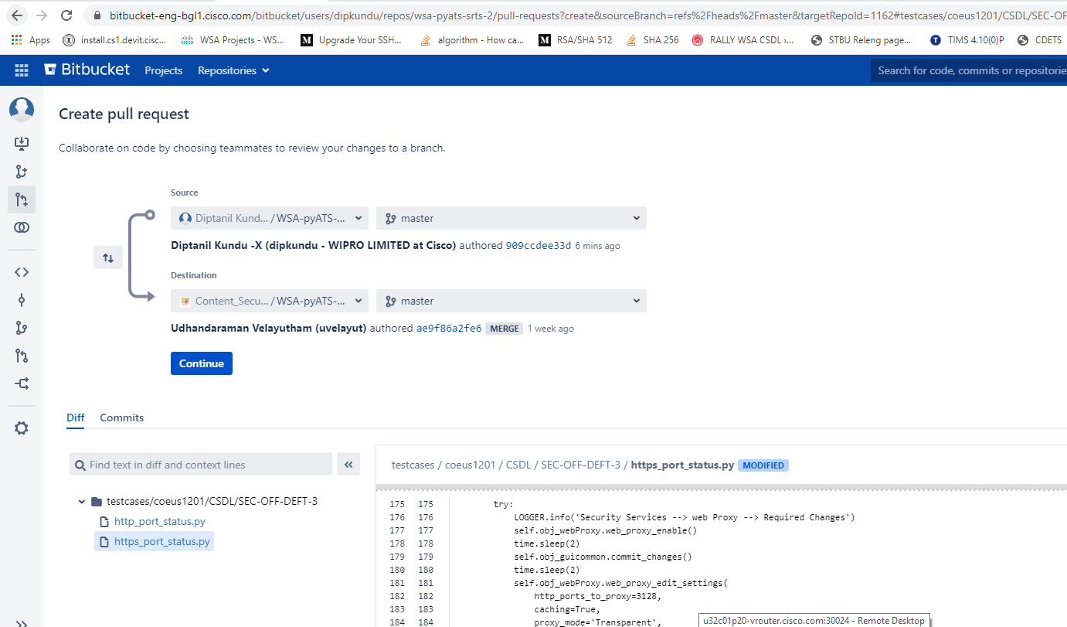

FOR P20 CLIENT 01:

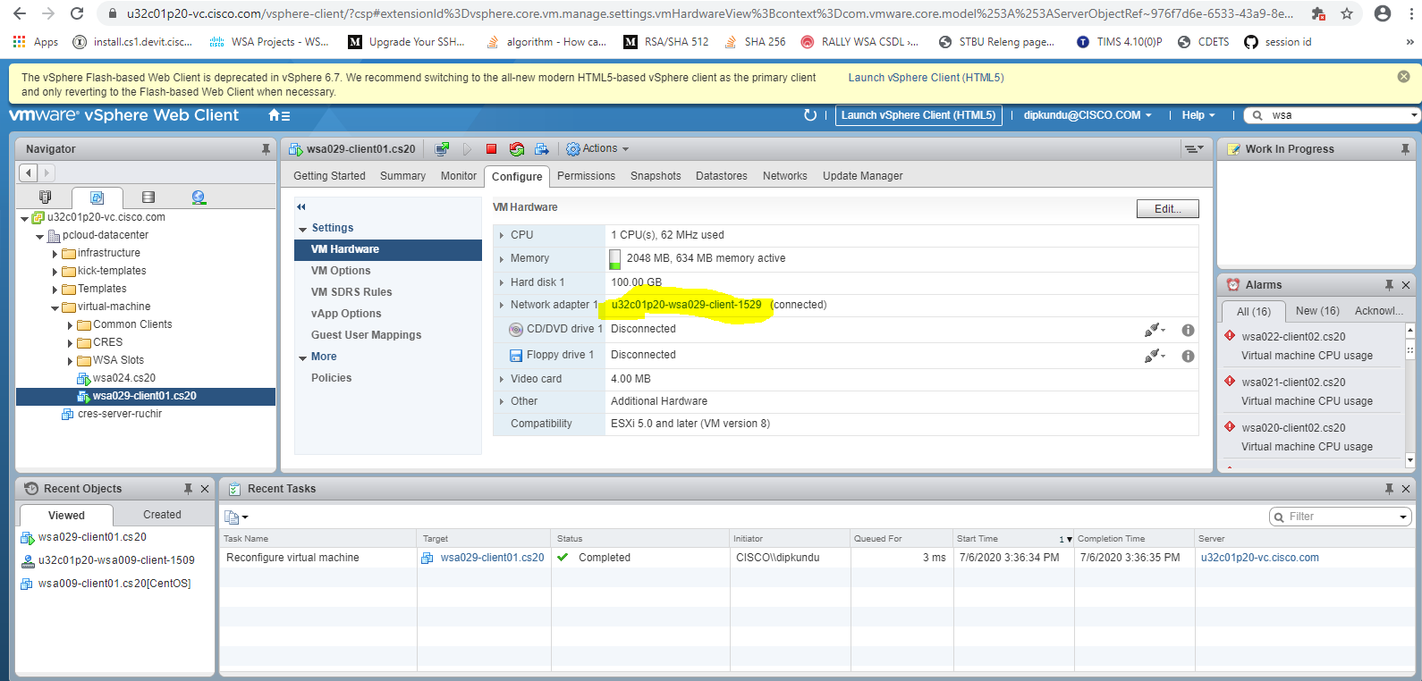

CentOS CLIENT AND SERVER CONFIGURATIONS:  
  
Login via testuser:  
  
sudo vi /etc/hostname- change hostname and save  
  
cd /etc/sysconfig/network-scripts  
  
sudo vi ifcfg-ens160 ------change gateway , hostname, ipaddress and save

reboot  
  
sudo /etc/init.d/network restart  
  
ifconfig ens160  
  
netstat -nr

For red hat server:

/etc/sysconfig/network-scripts/ifcfg-eth0

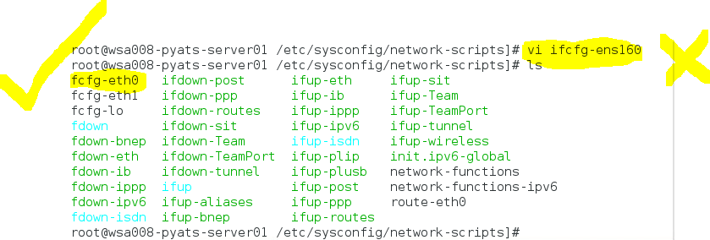

Ns lookup wsa029-pyats-ser01.cs20

Nslookup hostname for ip

Not always client05 is pyats server.

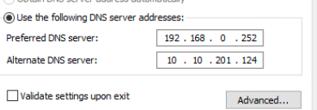

JENKINS SLOT ERROR:

GO TO THE DESIRED SLOT:

CHECK LOGS FOR THE ERROR TO DEBUG:

DISCONNECT THE SLOT FIRST

THEN GO TO THE PYATS SERVER AND CHECK IF /DATA/JENKINS IS PRESENT OR NOT.

CRETATE THE FOLDERS AND GIVE PERMISSION AND THEN LAUNCH

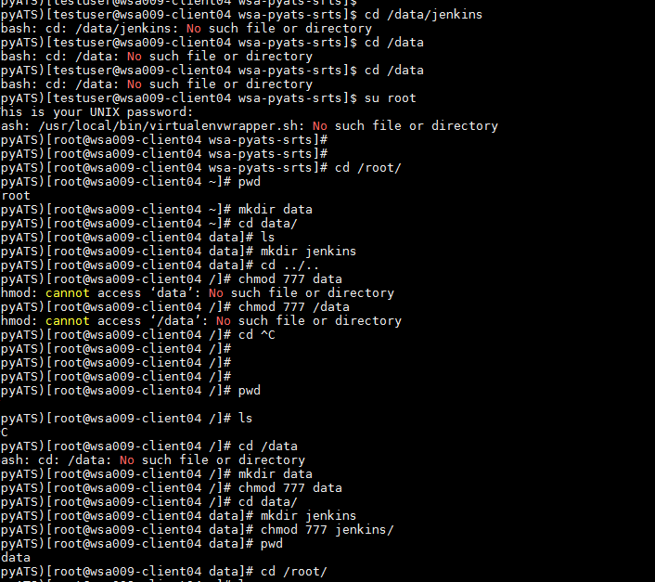

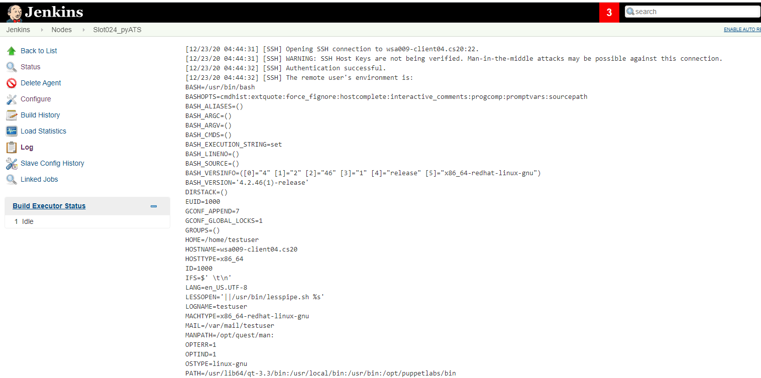

Testlib/common/util/routerconfig

ei line e 2 take 1 kore chalate hobe: m = re.match('0*(.{1,})', self.slot)

P1: ADD DNS , GATEWAY, PING WSA040-P1.CS1 TO KNOW THE IP AND then add the ip and gate way.

Netmask : p1 er 27

Gateway will be P1 ip minus 1

Nslookup wsa040-p1.cs1

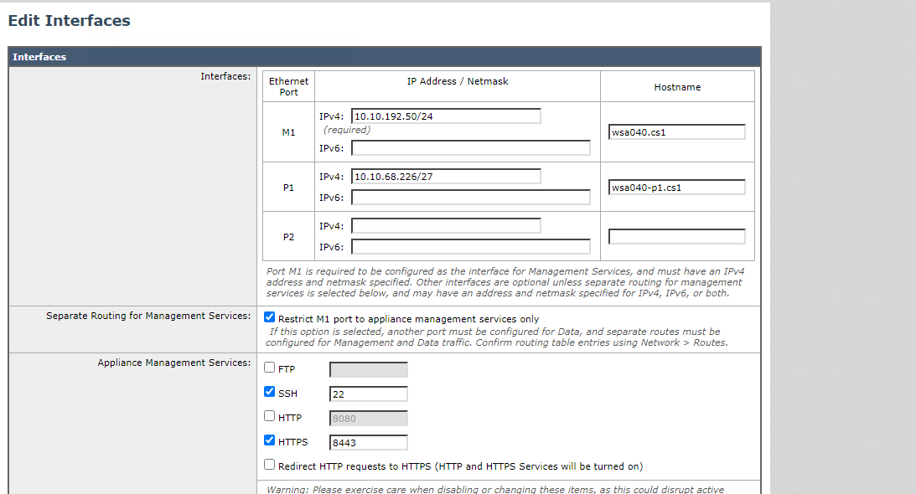

default route ta edit koro

new add korte hobena

click om restric m1 and commit

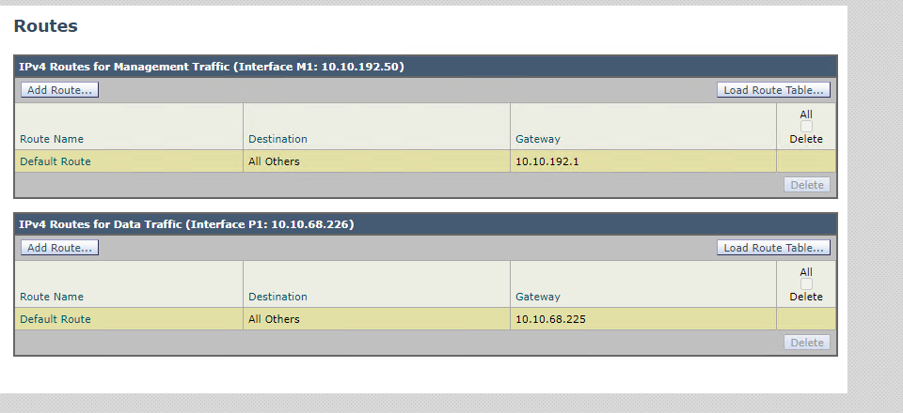

change hyper package: find / -iname connection.py

/work/pyATS/lib/python2.7/site-packages/hyper/http20/connection.py

/work/pyATS/hyper-development/hyper/http20/connection.py

HOW TO JOIN AN AD SERVER WITH WINDOWS CLIENT

LOGIN TO THE WINDOWS CLIENT(WSA034-CLIENT03.CS1)

THEN GO PC -> ADMIN SETTING -> CHANGE THE DOMAIN NAME TO : WIN2016-AD126.CS1

CHANGE THE NETWORK DNS TO AD SERVER IP

Join domain : [WIN2016-AD126.CS1-Administrator/Ironport@1234](mailto:WIN2016-AD126.CS1-Administrator/Ironport@1234)

Change prefix to same : WIN2016-AD126.CS1

Restart and login with switch user : ADNAME/Administrator

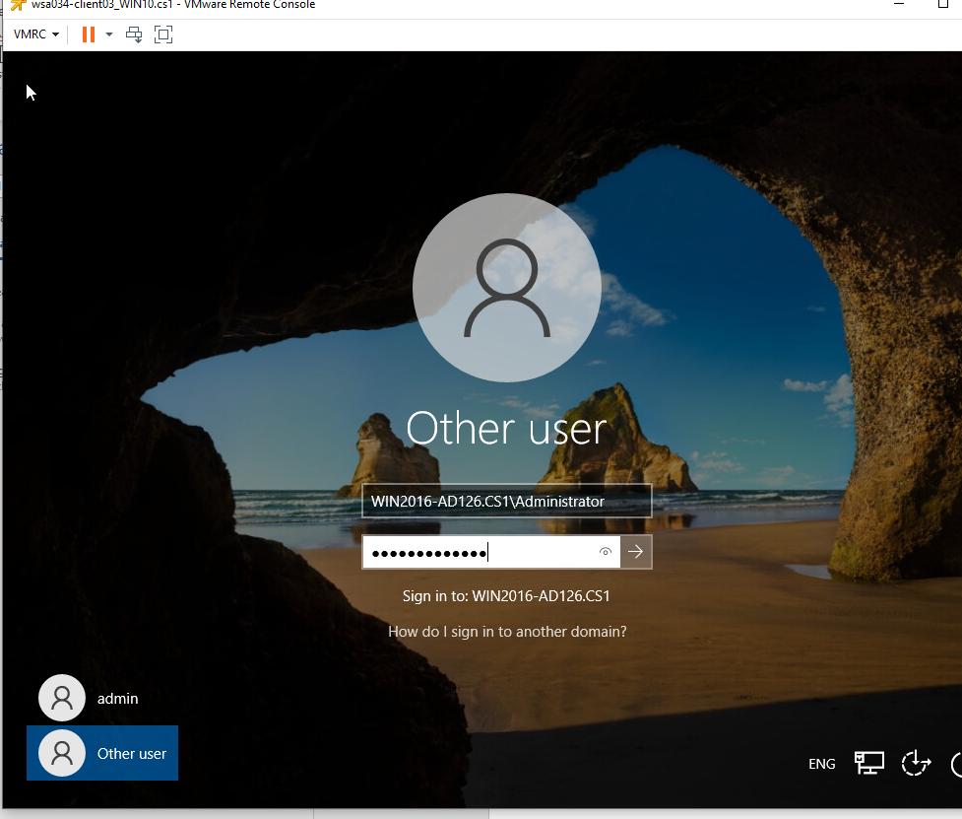

Now open browser and test

SambaNTLMUser/Cisco123$

To revert back change : WORKGROUP

To create was use : S300v_vWSA_pCloud07_template [HDD : 500G]

KERBEROS:

/root/Kerberos(create the folder in client)

vi krb5.conf FROM CLIENT

#!/bin/bash

2 [libdefaults]

3 default_realm=W2016-AD125.CS1

4 dns_lookup_realm = yes

5 dns_lookup_kdc = yes

6

7 [realms]

8

9 W2016-AD125.CS1 = {

10

11 kdc = 10.10.201.125

12

13 }

~

Wsa040-clinet05.cs1 for the file reference

export KRB5_CONFIG=/root/Kerberos/krb5.conf

kinit -f -p sambacommonuser@W2016-AD125.CS1

Password for sambacommonuser@W2016-AD125.CS1:

[root@wsa040-pyats-server01 Kerberos]#

Klist

curl -vvv -4 -x wsa040-p1.cs1:3128 --proxy-negotiate -u : -o /dev/null https://www.bbc.com -k

IPFW BLOCK: AUTH SERVICE UNAVIALBE:

IPFW: SERVICE UNAVIALABLE: ipfw add 100 deny ip from me to 10.10.201.4

allow:

curl:

curl -vvv -x wsa008-p1.cs20:3128 --tlsv1.2 --proxy-ntlm --proxy-user 'AD02.CS20\sambauser01:Cisco123$' -o /dev/null https://www.facebook.com -k

1625849436.378 107 10.10.0.226 TCP_DENIED/407 0 CONNECT tunnel://www.facebook.com:443/ - NONE/- - OTHER-NONE-IDNTLM-NONE-NONE-NONE-NONE-NONE <"-",-,-,"-",-,-,-,-,"-",-,-,-,"-",-,-,"-","-",-,-,"-",-,"-","-","-","-","-","-","-",0.00,0,-,"-","-",-,"-",-,-,"-","-",-,-,"-",-,-> - - x-mech= NONE group = -

1625849436.670 290 10.10.0.226 TCP_MISS_SSL/200 39 CONNECT tunnel://www.facebook.com:443/ "-*@NTLMREALM2012" DIRECT/www.facebook.com - DECRYPT_WEBCAT_7-DPNTLM-IDNTLM-NONE-NONE-NONE-DefaultGroup-NONE <"IW_snet",3.9,-,"-",-,-,-,-,"-",-,-,-,"-",-,-,"-","-",-,-,"IW_snet",-,"-","Social Networking","-","Unknown","Unknown","-","-",1.08,0,-,"-","-",-,"-",-,-,"-","-",-,-,"-",-,-> - - x-mech= NTLMSSP group = -

1625849437.260 588 10.10.0.226 TCP_MISS_SSL/200 220667 GET https://www.facebook.com:443/ "-*@NTLMREALM2012" DIRECT/www.facebook.com text/html DEFAULT_CASE_12-APNTLM-IDNTLM-NONE-NONE-NONE-DefaultGroup-NONE <"IW_snet",3.9,1,"-",0,0,0,1,"-",-,-,-,"-",1,-,"-","-",-,-,"IW_snet",-,"Unknown","Social Networking","-","Facebook General","Facebook","-","-",3002.27,0,-,"Unknown","-",1,"-",-,-,"-","-",-,-,"-",-,-> - - x-mech= NTLMSSP group = -

block:

1625829170.683 1 10.10.0.226 TCP_DENIED/407 0 CONNECT tunnel://www.facebook.com:443/ - NONE/- - OTHER-NONE-IDNTLM-NONE-NONE-NONE-NONE-NONE <"-",-,-,"-",-,-,-,-,"-",-,-,-,"-",-,-,"-","-",-,-,"-",-,"-","-","-","-","-","-","-",0.00,0,-,"-","-",-,"-",-,-,"-","-",-,-,"-",-,-> - - x-mech= NONE group = -

1625829170.696 4 10.10.0.226 TCP_DENIED/407 0 CONNECT tunnel://www.facebook.com:443/ "AD02.CS20\sambauser01" NONE/- - OTHER-NONE-IDNTLM-NONE-NONE-NONE-NONE-NONE <"-",-,-,"-",-,-,-,-,"-",-,-,-,"-",-,-,"-","-",-,-,"-",-,"-","-","-","-","-","-","-",0.00,0,-,"-","-",-,"-",-,-,"-","-",-,-,"-",-,-> - - x-mech= NONE group = -

Persistent Cookie – The Web Proxy tracks an authenticated user on a particular application by generating a persistent cookie for each user per application. Closing the application does not remove the cookie.

Session Cookie – The Web Proxy tracks an authenticated user on a particular application by generating a session cookie for each user per domain per application. (However, when a user provides different credentials for the same domain from the same application, the cookie is overwritten.) Closing the application removes the cookie.

session cokkie browser close kore dile sesh hoe jai

persistent ta surrogate time obdi thake

Thu Aug 22 13:47:59 2019 Debug: PROX_AUTH : 4777 : Adding Master Cookie for 10.10.13.228 with (domain=wsa112-p1.cs1 and expiration=Thu, 22 Aug 2019 13:49:29 GMT)

auth log

persistent

persistent cookie mozila support kore na chrome die koris

Persistent ta tahole somewhat same as Ip address surrogate , only difference is HTTP website diye korte hobe

session cookie ta mozilla diye korte bolcho and Persistent ta Chrome diye

Thu Aug 22 11:07:37 2019 Debug: PROX_AUTH : 643 : Adding Master Cookie for 10.10.13.228 with (domain=wsa112-p1.cs1 --session cookie

WSA CREATION:

There were 2 things wrong.

Managment interface was associated with wrong VLAN. It was associated with 192 instead of 194.

WSA resources mapping was wrong, for S300V we should associate 5 cores and 12 GB RAM. It was with 4 cores and 8 GB RAM.

Now I have corrected that and started net-install, it should come up in few minutes.